Extracting Patterns via Clustering and Associated
Quality Metrics from Educational Traces

1st Author
1st author's affiliation
1st line of address
2nd line of address
Telephone number, incl. country code
1st author's E-mail address
2nd Author
2nd author's affiliation
1st line of address
2nd line of address
Telephone number, incl. country code
2nd E-mail
3rd Author
3rd author's affiliation
1st line of address
2nd line of address
Telephone number, incl. country code
3rd E-mail

ABSTRACT
Clustering algorithms, pattern mining techniques and associated quality metrics emerged as reliable methods for modeling learners in given educational scenarios. The specificity of available data such as missing values, extreme values or outliers, creates a challenge for extracting user models with educational significance. In this paper we introduce a pattern detection mechanism within a data analytics instrument based on sequential k-means clustering with SSE, silhouette, Dunn index and Xie Beni index quality metrics. Experiments performed on a dataset obtained from our online e-learning platform show that the extracted interaction patterns were significant in classifying learners. Furthermore, the performed monitoring created a strong basis for generating automatic feedback to learners in terms of their course participation while relying on previous performances. Moreover, our analysis creates automatic triggers for tutors by highlighting learners that will potentially fail the course, enabling them to take timely actions. A roadmap for implementing successful methodologies based on learning analytics for pattern detection is also discussed.
Categories and Subject Descriptors
D.5.3 [Artificial Intelligence]: Pattern Recognition: Clustering – similarity measures.
K.3.1 [Computing Milieux]: Computers and Education – Computer uses in education – computer-assisted instruction
General Terms
Algorithms, Measurement, Performance, Experimentation.
Keywords
k-means, Clustering validation, pattern detection, automatic feedback

INTRODUCTION
Finding patterns by learning analytics represents a research issue that has been addressed in various contexts. For example, Bilkinsen et. al. [27] use the learning analytics to detect patterns in the learning of Computer Programming by using methods from machine learning and trying to predict final grades.
Clustering algorithms represent the de facto method for finding items that naturally group together. From this perspective, there is a fair wide range of clustering algorithms differentiated mainly in three classes: hierarchical, non-hierarchical and spectral.
In terms of available data, in educational domain items may be represented by actors (e.g., students or professors), or learning assets (e.g., concepts, quizzes, assignments, etc.). Due to the rich variety of e-Learning platforms there is also a wide variety of structured data such as PLSC DataShop [28] or UCI Machine Learning Repository Student Performance Data Set [29].
Under these circumstances, designing and running a clustering process on a particular dataset in an attempt to find meaningful educational results that solve a given educational problem represents a challenge that is usually addressed to data analysis researchers or practitioners.
In this paper we propose an automatic feedback mechanism which has as key ingredients a pattern finding data analysis process in educational data.
Our approach for pattern finding is based on continuous evaluation in terms of clustering quality metrics (CQM) on data models produced by sequential k-means algorithm and outlier/extreme values automatic marking and manual removal by means of visual analytics.
From an educational perspective, discovered patterns are labeled accordingly giving us the possibility to characterize new students and thus provide them and their professors with feedback automatically messages in a personalized way.
The main contributions regard the following aspects:
- Identify relevant CQM and implement them in Weka. Currently, Weka does not implement any CQM and does not have a standard way of returning data models (i.e., cluster assignments, standard CQMs).
- Develop an instrument that is suited for finding patterns and providing automatic feedback.
- Define of a methodology validated through experiments on available data and interpret results having in mind the educational perspective and task.
The paper discusses the key findings for the particular data analyzed context, point out strengths and limitations and provide a roadmap for the future works such that the addressed educational task may be solved efficiently.

RELATED WORKS
The quality of a clustering process is strongly related to the following ingredients: available dataset, chosen clustering algorithm and implemented CQM. The available domain specific training data for the clustering process and CQMs provide necessary building blocks for interpreting results in correspondence with proposed learning analytics task.
In educational domain there are several datasets suited for clustering. For experimental results we have used a dataset from Tesys e-Learning Platform [1].
For running the clustering processes we used simple k-means [7] clustering algorithm implemented in Weka [2]. Weka also implements EM [6] and COBWEB [3] for hierarchical clustering, and DBSCAN [4, 5]. The main drawback of Weka regards the lack of implemented CQMs such that clustering processes may be easily and reliably analyzed and the different ways in which Weka outputs clustering results of various clustering algorithms.
There are many CQMs that were defined in literature and these may be of various types depending approach: similarity metrics, clustering evaluation, clustering properties, distance measures, clustering distances, and cluster validity measures.
Jackson et. al [8] define similarity metrics as a way to compute the coupling value between two clusterings. The distance, association and correlation coefficients defined by Sneath et. al. [10] are: Taxonomic (distance), Camberra (distance), Jaccard (association), Simple matching (association), Sorensen-Dice (association), Correlation (correlation).
The clustering evaluation methodology called silhouette statistic as proposed by Rousseeuw in [11, 12]. Silhouette analysis and visualization technique has been successfully used used as main analytic engine for cluster analysis of student activity in a web-based intelligent tutoring system by Jugo et. al. [13].
The clustering properties were defined by Hompes et. al in [14] and are: cohesion, coupling, balance and clustering score. This methodology evaluates weighted scoring function, which grades an activity clustering with a score between 0 (bad clustering) and 1 (good clustering).
The similarity measures between two clusterings defined by Meila et. al. in [15, 16] are: Clustering Error (CE), the Rand index [34] (as a well-known representative of the point pair counting-based methods), and the Variation of Information (VI) [15]. The main goal of the proposed external measures is to provide a framework for comparing clusterings in term of similarity.
For comparing clusterings there were also defined the following clustering distances: Wallace indices [17], Fowlkes-Mallows index [18], Jaccard index [19], and Mirkin metric [20]. These distance measures are necessary in external cluster validation, stability based internal cluster validation, meta-clustering, and many cases of consensus clustering [16].
Cluster validity measures are defined by Stein et. al. in [21]: precision, recall, f-measure, Dunn index, Davies-Boulden, Λ measure, ρ measure. These internal measures determine the usefulness of obtained clusters in terms of structural properties.
From the information theory point of view, CQMs should meet the following axioms set by Kleinberg: scale invariance, consistency, and richness and also the ones proposed by [22]: relative point margin, representative set, relative margin.
Irrespective of CQM point of view, the common distance metrics among items are: Euclidian, Minkowski, and cosine [23] with several associated properties such as: penalty, background, scale invariant [15].
Still, the most common used function that is minimized when inferring clusters in k-means algorithm is SSE (Sum of squared errors). Minimization of this objective function represents the main goal and of k-means algorithm and may be regarded as a baseline quality threshold in a clustering process.
From the application development perspective, many educational applications make intensive use of clustering processes. Bogarin et. al. [24] improve the educational process by clustering, Li et. al [25] performs user modeling via clustering, Bian Haiun [25] clusters educational data to find meaningful patterns, and examples may continue in the area of visualization, recommenders systems or information retrieval.

METHODOLOGY, METHODS AND MATERIALS
The learning analytics pipeline is built by two modules, one for data processing and one for visual analytics. The data processing is performed on server side, where the raw data and the e-Learning platform reside. The visual analytics are performed in a thin client represented by a Java applet.
Figure 1 presents the high level flow diagram of the learning analytics pipeline.
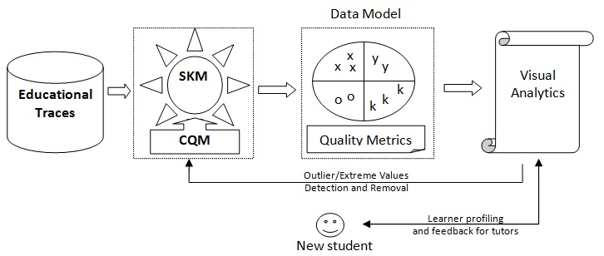
Figure 1. Data analytics pipeline

Input Dataset and Tesys e-Learning platform
The input dataset has been obtained by logging activity data performed in one year by students while running Tesys e-Learning platform. The platform has implemented specific logging methodology such that ray activity data is recorded into underlying database system. For computing numerical attributes that define each student a Tesys Data Manager tool was used, which preprocesses the raw data and outputs a file in xml and arff formats.
Tesys e-Learning platform is a Web application that implements a role based architecture where students, professors and administrators perform their activity. The activities performed by the students that are logged and transformed into numerical attributes are of three types: logging activity, messaging activity and quiz answering activity. Each attribute will be described in detail in section 4, where experimental results are presented.

Data Processing Module
The data processing module builds the data model from the input data. The main characteristics of this module regard the used algorithm and associated CQM. The output of this module is represented by the data model (i.e., the assignment of items into clusters) and the computed quality metrics.
The output of the data processing module is packaged as an xml file and is ready to be loaded and displayed by the visual analytics module.
Besides the data model itself, the data processing module is also responsible for determining outliers and extreme values according with setup and threshold values set by the data analyst in a configuration file. Among the common parameters set for this module we mention the used algorithm and the number of clusters.

Visual Analytics Module
This module displays the obtained clusters and marks outliers and extreme values as described in the data model received from the data processing module. Its main goal is to present the model to the data analyst, which needs to have domain knowledge and a proper visualization with educational meaning such that decisions may be taken. Among the most common decisions that may be taken are the manual removal of outliers and extreme values under continuous evaluation of CQMs and centroid values.
The centroid points are the representative students and inspection of their attribute values collaborated with domain knowledge may reveal interesting patterns that may be labeled accordingly. From this point of view, the design of this data analysis pipeline allows continuous trial and error sessions for the data analyst until educational relevant results are obtained.
The main characteristic of this module and of the entire pipeline itself is that it gives data analyst two types to information –numerical by means of CQMs and visual by spatially presenting clusters, centroids and outliers/extreme values – that allow him to properly decide if the current result is satisfactory or what to have a clear indication of what he should do next in order to converge towards a better result.

Characterization and Feedback
Once the patterns have been identified, the characterization of a new student may be done. Assuming that there have been identified three clusters of students labeled as “low”, “average” and “high”, the new students may be characterized as belonging to the cluster which has its centroid closer to him. For example, in Figure 2, “average” is the actual label that is being assigned to the new student.
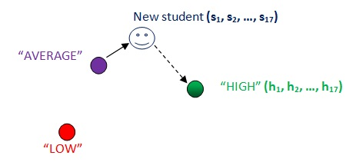
Figure 2. New student profiling
Once the actual label is determined, the target label may be also automatically determined because the total order among labels is already set by the domain knowledge data analyst. The dotted line represents the “road” that the new student needs to take in order to improve his knowledge level.
For determining the necessary course of action, which becomes the automatic feedback, the parameters where large differences are observed need to be taken into consideration.

EXPERIMENTAL RESULTS
The input dataset consists of 558 items (i.e., students) defined by 17 parameters. The description of the parameters is presented below.
A. Session parameters
TOTALSES – total number of sessions started by the user.
W[i] – total number of sessions in week-day i, where i is takes values from 0 to 6.
B. Message parameters
MSG_TOTALSEND – total number of sent messages
MSG_TOTALRECV – total number of received messages
MSG_MEANSEND – the mean duration between two consecutive sent messages
MSG_MEANRECV – the mean duration between two consecutive received messages
MSG_TOTALSEND_WDS – total number of words from sent messages
MSG_TOTALRECV_WDS - total number of words from received messages
C. Self-testing parameters
TOTALQUEST – total number of answered questions
GOODQUEST – total number of correct answered questions
QUESTPERC – the percentage of correct answered questions
The initial running of SKM algorithm produces the results in terms of SSE, Silhouette, Dunn index and Xi-Beni.
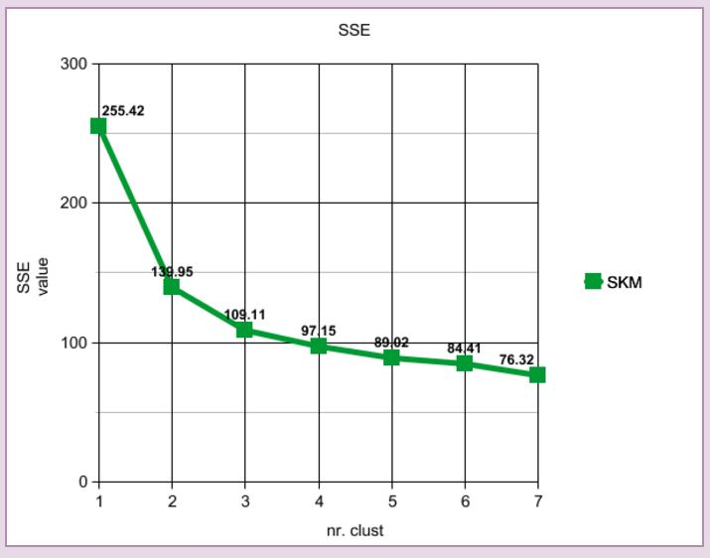
Figure 3. SSE values
Figure 3 shows an “elbow” for k equals to three clusters. Initially, for one cluster the SSE has the largest value, as expected, for two clusters a significant decrease is observed, of 45.2 % from SSE maximum value. From two clusters to three clusters there is also an important decrease of 22 % from SSE value obtained for two clusters. The consequent decreases in SSE values are smaller than 10 % thus leading to the conclusion that optimal values for k in terms of steepest descent may be two or three. Decision among these values is a matter of domain knowledge. For our case study we choose to make the analysis and discussion from three clusters. Choosing to discuss in terms of two clusters is also an option, especially if a clear discrimination among profiles is required from educational perspective. On the other side, for four clusters or more the decrease in SSE value is not significant this indicating that the quality of obtained clusters is not relevant

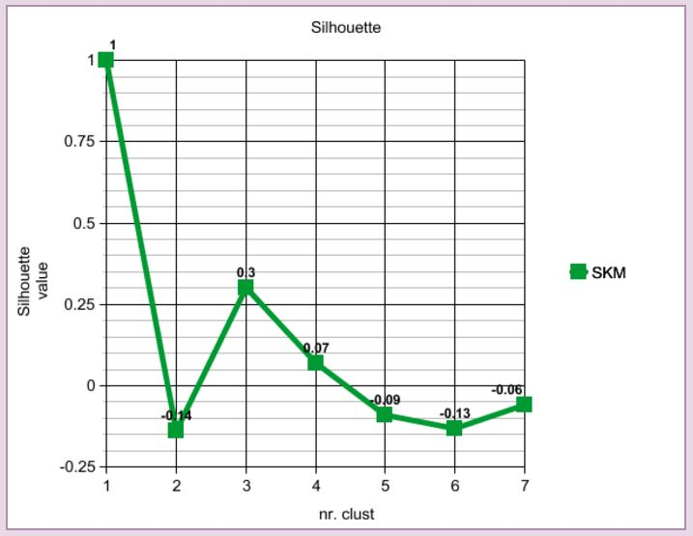
Figure 4. Silhouette values
The silhouette values are a clear indication regarding the quality of the obtained clusters. A value between 0.25 and 0.5 is an indication of a week structure while a value between 0.5 and 0.7 is an indication of a good structure. Due to the very nature of domain, we do not expect to have strong structures as in image processing. Since the items are represented by learners and parameters by performed activities we focus on the educational significance of obtained clusters in terms of their centroids, with a qualitative feedback from CQMs. The 0.3 value obtained for three clusters is by far the highest and this is a clear indication that three is the most appropriate number of clusters with reasonable structure that we obtain from available data. All other values are close to zero or negative, meaning that no substantial structure have been found.
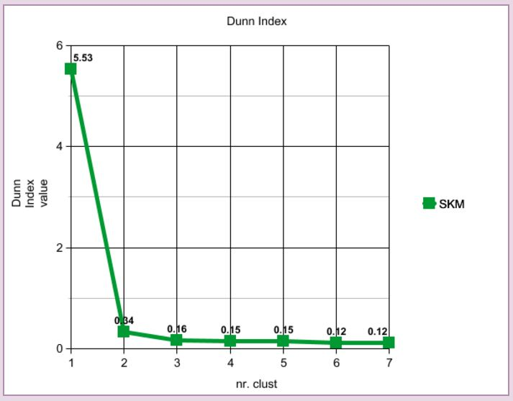
Figure 5. Dunn-index values
Dunn index values lays between zero and ∞ and should be maximized, large values indicating the presence of compact and well separated clusters. The obtained small values show that obtained clusters are not strong and this is usually due to presence of noise in the dataset. For our particular problem, this result yields to the conclusion that a high percentage extreme values and outliers are found in the dataset.

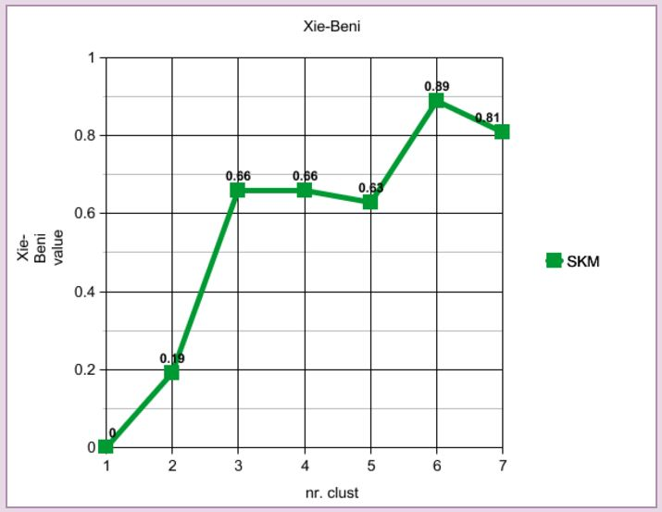
Figure 6. Xi-Beni values
Xi and Beni index has significance regarding the number of clusters when that value is a minimum for neighbor values. From this perspective, 2 and 5 clusters represent minimum “peaks” not taking into consideration the zero value for one cluster. Still, the index value for three clusters is 4.5% higher that the index value for five clusters and thus from educational perspective we may conclude that three clusters have more educational significance than five.
Figure seven presents the centroid’s feature values for the three obtained clusters. For each triple of features the smallest value was colored red, the middle value was colored purple and the largest value was colored green.
Considering the the centroids are the representative items for each cluster, we found out that a centroid has eleven red features, five purple features and only one green feature, thus indicating that this centroid has a clear dominance in red features. The second centroid has fifteen green features, three purple features and no red feature, thus indicating a clear dominance for green features. In the same way, the last centroid has a clear dominance for purple features which are eleven.
This analysis leads us to the conclusion that obtained centroids have educational significance in terms of knowledge weight, and thus labels “LOW”, “HIGH” and “AVERAGE” are assigned to corresponding centroid.
Figure 8 presents a print screen of the visual analytics application. For visualization purposes there were defined three new attributes, called Messaging Activity, Testing Activity and Loggin Activity. These new attributes are a digest of corresponding attributes as presented in table 1 and were computed by usage of PCA algorithm for dimensionality reduction.

Attribute name | Corresponding attributes
Messaging Activity | MSGTS, MSGTR, MSGMS, MSGMR, MSGWDS and MSGDS
Testing Activity | TQ, GQ, QP
Loggin Activity | TOTALSES, W0, W1, W2, W3, W4, W5, W6
Table 1. New attributes structure

For this initial run the centroids have the following values.
Figure 7. Centroid values

Figure 8. Clustering Applet with CQMs
//detalii despre oulier removal! Pamatertii, etc…
The outlier and extreme value removal led to the following Silhouette values.

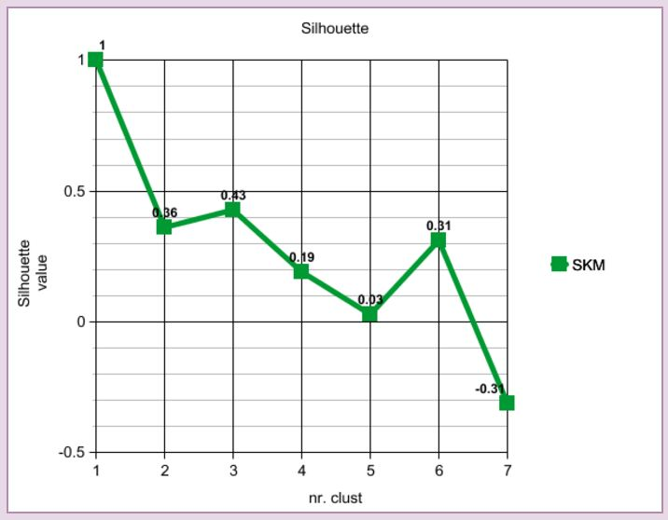
Figure 9. Silhouette values after outliers removal
Exemplu numeric cu new student
Detrminarea target label
Detrminarea paramerilor care trebuie imbunatatiti
Pe baza paramerilor determinate se construieste feedback

CONCLUSIONS
Future works:
Implementation and integration in Weka Workbench of other quality metrics, such as R-squared, Modified Hubert statistic, Calinski-Harabasz index, I index, Davies-Bouldin index, SD validity index [17. Understanding of Internal Clustering Validation Measures_Liu.pdf].
Visual learning analytics for:
- Correlation with user’s perception of quality from educational perspective. The user is a domain knowledge person, as a professor.
- Integration of other clustering algorithms.

ACKNOWLEDGMENTS
Tesys.

REFERENCES
- Burdescu, Dumitru Dan, Mihaescu, Marian Cristian, TESYS: e-Learning Application Built on a Web Platform. ICE-B 2006 - Proceedings of the International Conference on e-Business, Setúbal, Portugal, August 7-10, 2006.
- Mark Hall, Eibe Frank, Geoffrey Holmes, Bernhard Pfahringer, Peter Reutemann, Ian H. Witten (2009); The WEKA Data Mining Software: An Update; SIGKDD Explorations, Volume 11, Issue 1.
- Sanjoy Dasgupta, Performance guarantees for hierarchical clustering, Department of Computer Science and Engineering University of California, San Diego.
- Ester, Martin; Kriegel, Hans-Peter; Sander, Jörg; Xu, Xiaowei (1996). Simoudis, Evangelos; Han, Jiawei; Fayyad, Usama M., eds. A density-based algorithm for discovering clusters in large spatial databases with noise. Proceedings of the Second International Conference on Knowledge Discovery and Data Mining (KDD-96). AAAI Press. pp. 226–231. ISBN 1-57735-004-9.
- Hans Peter Kriegel, Peer Kröger, Jörg Sander, Arthur Zimek (2011). "Density - based Clustering".WIREs Data Mining and Knowledge Discovery 1 (3): 231 – 240. doi:10.1002/widm.30.
- A. P. Dempster; N. M. Laird; D. B. Rubin. Maximum Likelihood from Incomplete Data via the EM Algorithm, Journal of the Royal Statistical Society. Series B (Methodological), Vol. 39, No. 1. (1977), pp.1 - 38.
- J. B. MacQueen (1967): "Some Methods for classification and Analysis of Multivariate Observations, Proceedings of 5-th Berkeley Symposium on Mathematical Statistics and Probability", Berkeley, University of California Press, 1:281-297.
- Mihaescu Marian Cristian, Burdescu Dumitru Dan, Using M Tree Data Structure as Unsupervised Classification Method, Informatica - An International Journal of Computing and Informatics, Volume 36, Number 2, ISSN: 0350 - 5596, pp. 153 - 160, 2012.
- Donald A. Jackson , Keith M. Somers and Harold H. Harvey, Similarity Coefficients: Measures of Co-Occurrence and Association or Simply Measures of Occurrence?, The American Naturalist Vol. 133, No. 3 (Mar., 1989), pp. 436-453.
- Sneath, Peter H. A.; Sokal, Robert R. (1963). Principles of numerical taxonomy (7 ed.). San Francisco: W.H. Freeman. ISBN 0-7167-0621-0.
- Rousseeuw, P. J., Silhouettes: A graphical aid to the interpretation and validation of cluster analysis. Journal of Computational and Applied Mathematics, 20:53–65, 1987.
- Kaufman, L., Rousseeuw, P. J., Finding Groups in Data. An Introduction to Cluster Analysis. Wiley-Interscience, New York, 1990.
- Igor Jugo, Božidar Kovačić, Edvard Tijan, Cluster analysis of student activity in a web-based intelligent tutoring system, Scientific Journal of Maritime Research, Scientific Journal of Maritime Research 29 (2015), pp. 75-83.
- B.F.A. Hompes, H.M.W. Verbeek and W.M.P van der Aalst, Finding Suitable Activity Clusters for Decomposed Process Discovery, pp. 16-30, 4th International Symposium on Data-Driven Process Discovery and Analysis SIMPDA 2014 November 19-21, 2014, Milan, Italy.
- M. Meila, “Comparing Clusterings by the Variation of Information,” Proc. 16th Ann. Conf. Computational Learning Theory, pp. 173-187, 2003.
- Anne Patrikainen and Marina Meila, Comparing Subspace Clusterings, IEEE TRANSACTIONS ON KNOWLEDGE AND DATA ENGINEERING, VOL. 18, NO. 7, JULY 2006.
- D.L. Wallace, “Comment,” J. Am. Statistical Assoc., vol. 78, no. 383, pp. 569-576, 1983.
- E.B. Fowlkes and C.L. Mallows, “A Method for Comparing Two Hierarchical Clusterings,” J. Am. Statistical Assoc., vol. 78, no. 383, pp. 553-569, 1983.
- W.M. Rand, “Objective Criteria for the Evaluation of Clustering Methods,” J. Am. Statistical Assoc., vol. 66, pp. 846-850, 1971.
- B. Mirkin, Mathematical Classification and Clustering. Kluwer Academic Press, 1996.
- Benno Stein, Sven, Frank Wiβbrock, On Cluster Validity and the Information Need of Users In Proc. 3rd IASTED International Conference on Artificial Intelligence and Applications (AIA'03) (2003), pp. 404-413.
- Shai Ben-David, Margareta Ackerman, Measures of clustering quality: A working set of axioms for clustering, Advances in neural information processing systems, pp. 121-128, 2009.
- Pavel Zezula, Giuseppe Amato, Vlastislav Dohnal, and Michal Batko. 2010. Similarity Search: The Metric Space Approach (1st ed.). Springer Publishing Company, Incorporated.
- Alejandro Bogarín, Cristóbal Romero, Rebeca Cerezo, and Miguel Sánchez-Santillán. 2014. Clustering for improving educational process mining. In Proceedings of the Fourth International Conference on Learning Analytics And Knowledge (LAK '14). ACM, New York, NY, USA, 11-15. DOI=10.1145/2567574.2567604 http://doi.acm.org/10.1145/2567574.2567604
- Cen Li and Jungsoon Yoo. 2006. Modeling student online learning using clustering. In Proceedings of the 44th annual Southeast regional conference (ACM-SE 44). ACM, New York, NY, USA, 186-191. DOI=10.1145/1185448.1185490 http://doi.acm.org/10.1145/1185448.1185490
- Haiyun Bian, Clustering Student Learning Activity Data, Pp. 277-278, Baker, R.S.J.d., Merceron, A., Pavlik, P.I. Jr. (Eds.) Proceedings of the 3rd International Conference on Educational Data Mining.
- Paulo Blikstein, et. al., Programming Pluralism: Using Learning Analytics to Detect Patterns in the Learning of Computer Programming, THE JOURNAL OF THE LEARNING SCIENCES, 00: 1–39, 2014, [18]
- Koedinger, K.R., Baker, R.S.J.d., Cunningham, K., Skogsholm, A., Leber, B., Stamper, J. (2010). A Data Repository for the EDM community: The PSLC DataShop. In Romero, C., Ventura, S., Pechenizkiy, M., Baker, R.S.J.d. (Eds.) Handbook of Educational Data Mining. Boca Raton, FL: CRC Press.
- P. Cortez and A. Silva. Using Data Mining to Predict Secondary School Student Performance. In A. Brito and J. Teixeira Eds., Proceedings of 5th FUture BUsiness TEChnology Conference (FUBUTEC 2008) pp. 5-12, Porto, Portugal, April, 2008, EUROSIS, ISBN 978-9077381-39-7.

Columns on Last Page Should Be Made As Close As Possible to Equal Length

